* Copyright for test papers and marking guides remains with *West Australian Test Papers*.
* The papers may only be reproduced within the purchasing school according to the advertised conditions of sale.
* Test papers must be withdrawn after use and stored securely in the school until Friday 11th June, 2021.



**HUMAN BIOLOGY**

**Semester 1**

**2021**

Name: _______________________________________________________

Teacher: ___________________________________________________

**Time allowed for this paper**

Reading time before commencing work: ten minutes

Working time: two hours and thirty minutes

**Materials required/recommended for this paper**

***To be provided by the supervisor***

This Question/Answer booklet

Multiple-choice answer sheet

***To be provided by the candidate***

Standard items: pens (blue/black preferred), pencils (including coloured), sharpener, correction fluid/tape, eraser, ruler, highlighters

Special items: up to three calculators, which do not have the capacity to create or store programmes or text, are permitted in this ATAR course examination

**Important note to candidates**

No other items may be taken into the examination room. It is **your** responsibility to ensure that you do not have any unauthorised material. If you have any unauthorised material with you, hand it to the supervisor **before** reading any further.

**Structure of this paper**

|  |  |  |  |  |  |
| --- | --- | --- | --- | --- | --- |
| Section | Number of questions available | Number of questions to be attempted | Suggested working time (minutes) | Marks available | Percentage of examination |
| Section One  Multiple-choice | 30 | 30 | 40 | 30 | 30 |
| Section Two  Short answer | 8 | 8 | 70 | 100 | 50 |
| Section Three  Extended answer | 3 | 2 | 40 | 40 | 20 |
|  |  |  |  | **Total** | 100 |

**Instructions to candidates**

1. The rules for the conduct of the Western Australian external examinations are detailed in the *Year 12 Information Handbook 2021*. Sitting this examination implies that you agree to abide by these rules.

2. Write your answers in this Question/Answer booklet preferably using a blue/black pen. Do not use erasable or gel pens.

3. Answer the questions according to the following instructions.

Section One: Answer all questions on the separate Multiple-choice answer sheet provided. For each question, shade the box to indicate your answer. Use only a blue or black pen to shade the boxes. Do not use erasable or gel pens. If you make a mistake, place a cross through that square, then shade your new answer. Do not erase or use correction fluid/tape. Marks will not be deducted for incorrect answers. No marks will be given if more than one answer is completed for any question.

Section Two: Write your answers in this Question/Answer booklet. Wherever possible, confine your answers to the line spaces provided.

Section Three: Consists of three (3) questions. You must answer any two (2) questions. Tick the box next to the question you are answering. Write your answers in this Question/Answer booklet.

4. You must be careful to confine your answers to the specific questions asked and to follow any instructions that are specific to a particular question.

5. Supplementary pages for planning/continuing your answers to questions are provided at the end of this Question/Answer booklet. If you use these pages to continue an answer, indicate at the original answer where the answer is continued, i.e. give the page number.

**Section One: Multiple-choice 30% (30 Marks)**

This section has **30** questions. Answer **all** questions on the separate Multiple-choice answer sheet provided. For each question shade the box to indicate your answer. Use only a blue or black pen to shade the boxes. Do not use erasable or gel pens. If you make a mistake, place a cross through that square, then shade your new answer. Do not erase or use correction fluid/tape. Marks will not be deducted for incorrect answers. No marks will be given if more than one answer is completed for any question.

Suggested working time: 40 minutes.

1. Substances that can move directly through the phospholipid bilayer through simple diffusion include
   1. sodium ions.
   2. glucose molecules.
   3. oxygen molecules.
   4. ribonucleic acid.

Use the diagram of the phospholipid bilayer below to answer the questions 2-4.

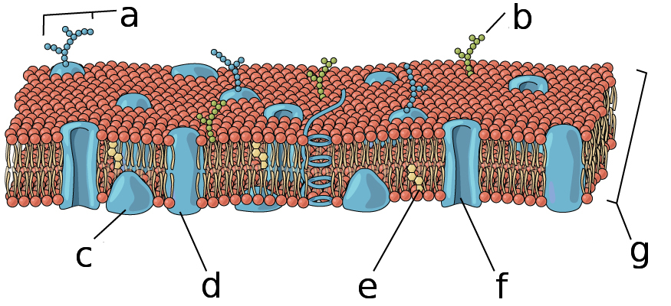

1. Which letter represents a peripheral protein?
   1. A
   2. B
   3. C
   4. D
2. Which letter represents cholesterol?
   1. D
   2. E
   3. F
   4. G
3. What structure is used to transport substances via facilitated diffusion?
   1. D
   2. E
   3. F
   4. G
4. As a cells size increases, the surface area to volume ratio
   1. decreases, causing rapid heat loss.
   2. increases, causing rapid heat loss.
   3. increases, causing difficulty in obtaining cell requirements.
   4. decreases, causing difficulty in obtaining cell requirements.
5. The test for Covid-19 analyses samples for the presence of antibodies in the body. The cells, which produce these antibodies and act to protect the body from foreign invaders, are known as
   1. thrombocytes.
   2. erythrocytes.
   3. platelets.
   4. leucocytes.
6. Sebaceous glands in our skin secrete an oily substance known as sebum that contains lipids. Which cell organelle would you expect to find in high numbers within the cells of these glands?
7. Ribosomes
8. Mitochondria
9. Smooth endoplasmic reticulum
10. Golgi body
11. The two sets of convolutions in the nephron allows for
12. decreased concentration gradients for better reabsorption.
13. an increase in surface area for reabsorption and secretion.
14. a rise in blood pressure for increased filtration.
15. minimal loss of filtrate during urine production.
16. The function of the cilia found in the epithelial cells of the trachea is to help move
17. mucus and debris out of the lungs.
18. air into the bronchioles.
19. mucus into the lower respiratory tracts.
20. air out of the mouth and nose.

Question 10 refers to the following graph showing the activity of an enzyme over a range of temperatures.

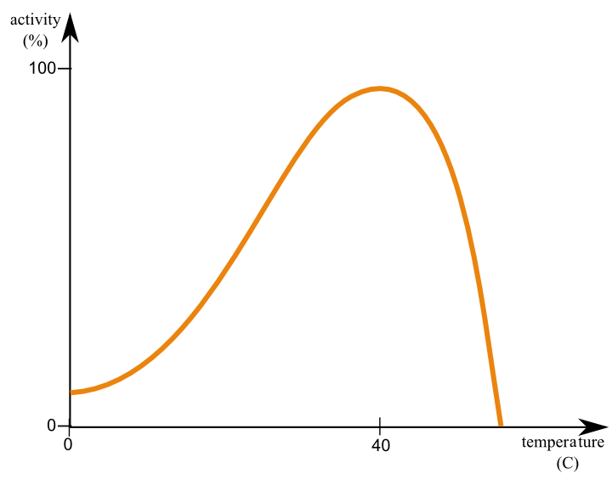

1. Which of the following explains the reduction in enzyme activity in the graph shown above?
2. Action of inhibitors increases
3. Substrates begin to break down
4. Active site changes shape
5. Product concentration increases
6. During a scientific investigation, several trials are run. Which of the following is the best reason to explain this?
7. Increase validity
8. Reduce effect of random errors
9. For the scientist to improve their skills
10. Increase accuracy
11. A typical pair of adult human lungs contains 480 million alveoli. The reason for this high number is to:
12. increase surface area for gas exchange.
13. increase the number of muscles to breath.
14. maintain the shape and keep the lungs inflated.
15. decrease pressure allowing air to be inspired.
16. Familial hypercholesteremia results from the failure of specific receptors on the cell membrane. The receptors allow low-density lipoproteins to be engulfed and ultimately lowers blood cholesterol levels. Patients suffering this genetic disorder are at risk of cardiovascular disease. The movement of these lipoproteins into the cells is best known as:
17. facilitated transport.
18. exocytosis.
19. active transport.
20. endocytosis.
21. The enzyme found in the human mouth starts the digestion of carbohydrates. Which of the following correctly identifies the name and optimal pH for this enzyme?
22. Amylase; pH 5
23. Maltase; pH 9
24. Amylase; pH 7
25. Maltase; pH 5

Questions 15 and 16 refer to the diagram below that shows the different organs associated with the digestive system.

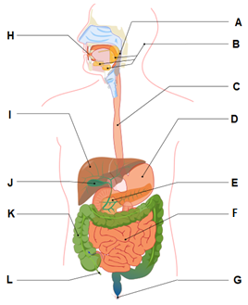

1. Achlorhydria is an autoimmune disease that damage mucosa cells and can cause impaired digestion of food. In which organ would these cells be found?
2. Organ C
3. Organ D
4. Organ E
5. Organ J
6. Which of the following is **not** a function of the organ labelled K?
7. Absorption of water and vitamins
8. Formation and storage of faeces
9. Breakdown of organic matter
10. Production of enzymes for chemical digestion
11. Which of the following statements **correctly** identifies the difference between elimination and excretion?
12. Excretion occurs mainly through faeces, whilst elimination occurs through urine.
13. Excretion removes indigestible material, whilst elimination removes metabolic wastes only.
14. Elimination occurs in several different organs, whilst excretion occurs only in the kidneys.
15. Elimination is the removal of indigestible material and metabolic waste, whilst excretion removes metabolic wastes only.
16. A student used a 10X ocular lens and a 40X objective lens to view a sample of tissue. A field of view of 300μm was measured. When the objective lens was changed to 10X, what would be the new field of view?
17. 1.2 mm
18. 7.5 mm
19. 120 μm
20. 75 μm
21. Coenzyme Q10 is required for the synthesis of adenosine triphosphate. Which of the following **best** explains how a coenzyme works?
22. Small organic and inorganic molecules that bind to the enzyme and change the shape of the active site.
23. Large protein molecules that permanently bind to enzymes and act as catalysts.
24. Organic molecules that temporarily bind to an enzyme and change their shape.
25. Inorganic molecules that produce chemical reactions between enzymes and substrates.
26. Compared to inhaled air, exhaled air should have a higher percentage of
27. nitrogen and oxygen.
28. carbon dioxide and nitrogen.
29. water vapour and carbon dioxide.
30. oxygen and water vapour.
31. Which one of the following statements is **incorrect** about systematic errors? These are
    1. unpredictable errors that can occur in all experiments.
    2. errors that cannot be reduced by averaging.
    3. errors that can only be eliminated by changing the experiment procedure.
    4. errors that occur because of the way in which an experiment is designed.
32. A potato tissue sample weighed 14.5 g at the start of an osmosis experiment and at the end it weighed 10.73 g. The percentage change is
    1. 26%
    2. -26%
    3. -35%
    4. 35%
33. Which one of the following statements about the cardiac cycle is **incorrect**?
    1. When the atria contract, the semi-lunar valves open.
    2. When the atria contract, the atrioventricular valves open.
    3. When the ventricles relax, the semi-lunar valves close.
    4. When the ventricles contract, the atrioventricular valves close.

Use the following information to answer Question 24.

The table below summarises measurements made of the concentration of the substances in the kidney filtrate of a person.

|  |  |  |
| --- | --- | --- |
| **Substance** | **Concentration (arbitrary units)** | |
|  | Filtrate | Urine |
| Protein Urea  Glucose Sodium | 0 300 1000 3000 | 0 20000 0 3000 |

1. The conclusions that water is reabsorbed in the tubules of the nephron is supported

by the data on the relative concentration of:

(a) protein

(b) urea

(c) glucose

(d) sodium

1. Bile is involved in the breakdown of fats. It is
   1. produced in the gall bladder and stored in the liver
   2. produced in the liver and stored in the gall bladder
   3. produced in the pancreas and stored in the liver
   4. produced and stored in the liver
2. Deamination is a process that occurs in the liver with the use of enzymes. The reactants are shown in the incomplete word equation as follows.

enzymes

amino acid + oxygen products

The products of the deamination are

* 1. urea + water
  2. carbon dioxide + ammonia
  3. urea + ammonia
  4. carbohydrate + ammonia

1. Which of the following is the best definition of ‘active transport’?
2. molecules moving through a cell membrane against the concentration gradient
3. molecules moving through a cell membrane using protein channels along a concentration gradient
4. molecules moving through a cell membrane using membranous sacs along a concentration gradient
5. water moving through a cell membrane against the concentration gradient
6. Which of the following statements about mechanical and/or chemical digestions is **correct**?
   1. Mechanical digestion takes place in the mouth and small intestines only.
   2. Chemical digestion takes place in the mouth, stomach, small and large intestines.
   3. Mechanical and chemical digestions take place in the mouth, stomach and small intestines.
   4. Mechanical and chemical digestions take place in the mouth, oesophagus, stomach and small intestines.
7. Which of the following best describes selective reabsorption in the kidney nephron?
   1. Active transport of Na⁺ from the proximal convoluted tubule cell towards a capillary.
   2. Facilitated transport of Na⁺ from the tubule lumen into the proximal convoluted tubule cell.
   3. Diffusion of water and plasma proteins from the proximal convoluted tubular cell towards a capillary.
   4. Diffusion of Na⁺ and Cl⁻ from the tubule lumen into the proximal convoluted tubule cell.
8. Filtration of blood in the glomerulus of the kidneys is primarily dependent on
9. concentration gradient
10. availability of ATP
11. blood pressure
12. diffusion rate

**End of Section One**

**Section Two: Short answer 50% (100 Marks)**

This section has **8** questions. Answer **all** questions. Write your answers in the spaces provided.

Supplementary pages for planning/continuing your answers to questions are provided at the end of this Question/Answer booklet. If you use these pages to continue an answer, indicate at the original answer where the answer is continued, i.e. give the page number.

Suggested working time: 70 minutes.

**Question 31 (13 marks)**

Chronic fatigue is most common in people between 40 and 60 years of age. D-ribose supplementation helps chronic fatigue by providing a substrate for cellular respiration to occur.

1. Complete the word equation for cellular respiration, which uses glucose as its substrate. (1 mark)

Glucose + _______________ 🡪 ________________ + Carbon Dioxide + ______________

1. Is the equation in part (a) an example of a catabolic or anabolic reaction? Justify your answer. (2 marks)

_________________________________________________________________________________________________________________________________________________________________________________________________________

1. Wastes produced from cellular respiration need to be excreted from the body. Identify which organ carbon dioxide is excreted from.

(1 mark)

______________________________________________________________________________________________________________________________________

A study in Great Britain found that 70% of patients suffering from Chronic Fatigue Syndrome had irregular mitochondrial structures.

1. Explain why an abnormal inner membrane of a mitochondria could lead to symptoms of fatigue. (5 marks)

_________________________________________________________________________________________________________________________________________________________________________________________________________

_________________________________________________________________________________________________________________________________________________________________________________________________________

____________________________________________________________________________________________________________________________________________________________________________________________________________________________________________________________________________

1. During exercise, chronic fatigue patients often experience a burning sensation in their

muscles along with a lack of strength. Explain why this occurs. (4 marks)

_________________________________________________________________________________________________________________________________________________________________________________________________________

______________________________________________________________________________________________________________________________________

_________________________________________________________________________________________________________________________________________________________________________________________________________

**Question 32 (13 marks)**

The diagram below shows major vessels and glands in the lymphatic system.

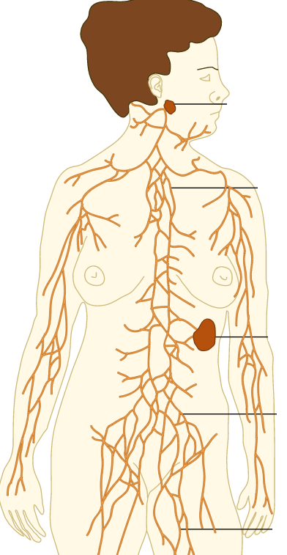

1. What is lymphatic fluid? In your answer state the major components that make up lymphatic fluid. (3 marks)

______________________________________________________________________

1. Describe **two (2)** functions of the lymphatic system (4 marks)

1. The lymphatic system is closely linked with the circulatory system. Contrast these two systems describing **three (3)** differences. (6 marks)

**Question 33 (13 marks)**

The diagram below shows a cross section of the small intestine.

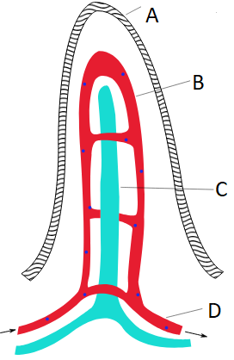

1. Label the structures. (4 marks)

A:

B:

C: _____________________________________________________________________

D: _____________________________________________________________________

1. State where in the structure above the following nutrients are absorbed. (4 marks)

Glucose:

Amino Acids:

Fatty Acids:

Glycerol:

1. Describe the ways the structure shown in question 33 on the previous page is suited to its function. (3 marks)

_________________________________________________________________________________________________________________________________________________________________________________________________________

1. Describe how the longitudinal and circular (transverse) muscles move ingested food through the digestive system. (2 marks)

_________________________________________________________________________________________________________________________________________________________________________________________________________

___________________________________________________________________

**Question 34 (7 marks)**

In 2010, a patient at Westmead hospital in New South Wales, Australia, received the incorrect blood during a transfusion resulting in an ABO incompatibility reaction.

1. Describe how type A and type B blood types differ. (4 marks)

_________________________________________________________________________________________________________________________________________________________________________________________________________

_________________________________________________________________________________________________________________________________________________________________________________________________________

1. Describe what occurs to the newly transfused blood during an ABO incompatibility reaction. (1 mark)

_________________________________________________________________________________________________________________________________________________________________________________________________________

1. Explain why people with O negative type blood are referred to as universal donors.

(2 marks)

___________________________________________________________________

______________________________________________________________________________________________________________________________________

**Question 35 (19 marks)**

The diagram below shows an alveolus surrounded by a capillary.

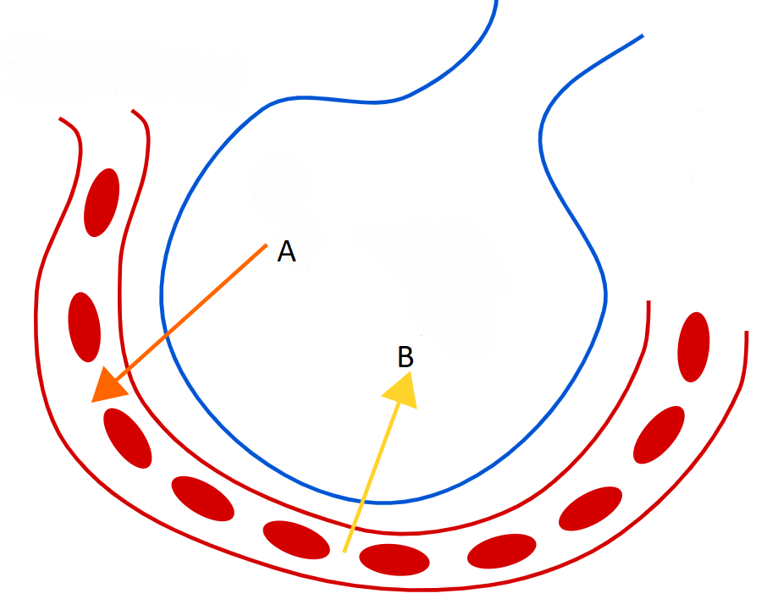

(a) Describe **four (4)** ways in which this structure is well suited to the function of gas exchange. (4 marks)

One:

Two:

Three:

Four:

(b) (i) Name gas A. _________________________________________________ (1 mark)

(ii) Explain how gas A is transported in the blood. (2 marks)

___________________________________________________________________________________________________________________________________________________________________________________________________________________________

(c) (i) Name gas B. _________________________________________________ (1 mark)

(ii) Explain how gas B is transported in the blood. (3 marks)

_____________________________________________________________________________________________________________________________________________________________________________________________________________________________________________________________________________________________________________________________________________________________________________

(d) Explain how efficient exchange of gas A and gas B occurs across the alveolar and capillary membranes. (4 marks)

(e) Describe the causes of asthma and the effects that occur in the lungs during an asthma attack. (4 marks)

**Question 36 (8 marks)**

Covid-19 leads to blood clots in an estimated 30% of critically ill patients.

1. Identify the component of blood that is associated with clotting and give a reason why it is important that blood clots. (2 marks)

_________________________________________________________________________________________________________________________________________________________________________________________________________

___________________________________________________________________

The inferior view of a heart, which has been dissected horizontally across its short axis, is shown below.

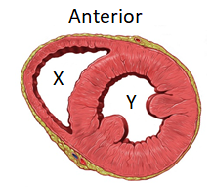

1. Identify the section labelled X and explain why its structure differs to that of the section labelled Y. (3 marks)

_________________________________________________________________________________________________________________________________________________________________________________________________________

_________________________________________________________________________________________________________________________________________________________________________________________________________

1. Covid-19 has also been shown to cause enlargement of the heart muscles. Describe how this would affect the structure and function of the section labelled Y.

(3 marks)

_________________________________________________________________________________________________________________________________________________________________________________________________________

_________________________________________________________________________________________________________________________________________________________________________________________________________

**Question 37 (14 marks)**

A year 11 Human Biology student was interested to find out how surface area to volume ratio would affect absorption. They made agar cubes that were dyed pink with phenolphthalein. The students made 3 sizes of cube. 5mm, 10mmand 15mm. The student then placed the cubes in an acid solution for 20 minutes. Phenolphthalein turns from pink to clear when it comes into contact with an acid. After 20 minutes the student used a ruler to measure the clear section of the cube which he then converted into a volume.

The results are found below.

|  |  |  |  |  |
| --- | --- | --- | --- | --- |
| Size of cube (mm) | Surface  Area (mm2) | Volume  (mm3) | Surface Area: Volume | Volume of acid absorbed (mm3) |
| 5 | 25 |  |  | 125 |
| 10 | 50 |  |  | 225 |
| 15 | 90 |  |  | 250 |

1. Complete the **Volume** column and **Surface Area:Volume** column in the table above.  
    (3 marks)
2. Propose an appropriate hypothesis for this investigation. (2 marks)

1. Name the independent and dependant variables for this investigation. (2 marks)

Independent variable:

Dependent variable:

1. In order to ensure valid results, a number of variables had to be controlled.  
   List **three (3)** of these. (3 marks)

1. Suggest a conclusion for this experiment regarding Surface Area:Volume and absorption. (2 marks)

1. The largest cell in the human body is an ovum which is 100µm. Using the information obtained from this experiment, suggest why cells cannot get any larger. (2 marks)

**Question 38 (13 marks)**

The diagram below illustrates a simplified version of an animal cell.

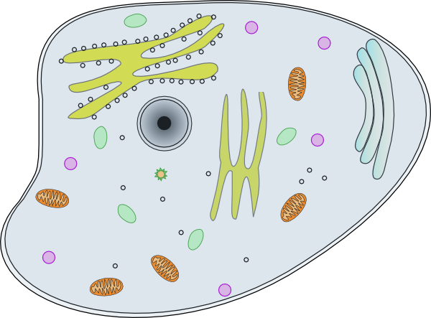

**Lysosome**

**C**

**E**

**B**

**As**

**D**

1. Identify the following organelles from the diagram above: (2 marks)

C: _________________________________

E: _________________________________

1. Describe how Organelle A and Organelle D work together to create lysosomes.

(2 marks)

_________________________________________________________________________________________________________________________________________________________________________________________________________

___________________________________________________________________

Digestion of proteins occurs in the stomach and small intestine through the activity of pepsin and trypsin enzymes, respectively.

1. Would you expect trypsin to have a higher or lower optimal pH level as compared to pepsin? Give a reason for your answer. (2 marks)

____________________________________________________________________________________________________________________________________________________________________________________________________________________________________________________________________________

1. Enzymes are specific to certain molecules. Draw a labelled diagram to illustrate the lock and key model during an anabolic reaction. (4 marks)

|  |
| --- |
|  |

The enzyme catalase breaks down hydrogen peroxide (H2O2) to form water and oxygen. The reaction rate can be calculated by measuring the height of bubbles formed per second. The incomplete graph below shows the results of an experiment that investigated the effect of substrate concentration in percentage on the activity of catalase.

1. Identify the saturation point for catalase in this experiment and describe how enzyme function is affected once saturation point is achieved. (3 marks)

__________________________________________________________________________________________________________________________________________________________________________________________________________________________________________________________________________________________________________________________________________________________________________________________________________________

**End of Section Two**

**Section Three: Extended answer 20% (40 Marks)**

This section contains **three (3)** questions. You must answer **two (2)** questions. Make sure you clearly indicate which question you are answering and write your answers in the space provided.

Use black or blue pen for this section. Only graphs and diagrams may be drawn in pencil. Responses can include: labelled diagrams with explanatory notes; lists of points with linking sentences; labelled tables and/or graphs; and/or annotated flow diagrams with introductory notes.

Supplementary pages for planning/continuing your answers to questions are provided at the end of this Question/Answer booklet. If you use these pages to continue an answer, indicate at the original answer where the answer is continued, i.e. give the page number.

Suggested working time: 40 minutes.

**Question 38 (20 marks)**

1. Water is a waste product that is produced by metabolism. Humans also take in water every day to ensure correct concentration.

Describe the three ways water is lost from the body. In your description name the organ give details about the process. (9 marks)

1. Describe the processes of filtration, secretion and reabsorption in the nephron   
    (11 marks)

**Question 39 (20 marks)**

1. There are six main methods in which materials are transported across cell membranes.

Describe how four (4) of these methods occur, the type of material that is transferred

and a specific example of where it occurs in the body.

(12 marks)

|  |
| --- |
| (b) Describe the mechanism by which air is drawn into and forced out of the lungs  during normal breathing. (8 marks) |
|  |

**Question 40 (20 marks)**

1. The normal heart rate for a healthy adult at rest is 60 to 70 beats per minute. Irregular heartbeats, such as during a heart attack, can affect the flow of blood through the heart and may even result in death.

Describe how blood normally flows through the heart and explain the effect on blood flow in the heart if the valve between the left atrium and ventricle was ineffective. (10 marks)

1. The system of vessels which distributes blood around the body is made up of THREE different types of vessels: arteries, veins and capillaries. Explain the difference in structure and function of each of these vessels. (10 marks)

**End of Questions**

Question number: _______________

_________________________________________________________________________

__________________________________________________________________________________________________________________________________________________

__________________________________________________________________________________________________________________________________________________

__________________________________________________________________________________________________________________________________________________

__________________________________________________________________________________________________________________________________________________

__________________________________________________________________________________________________________________________________________________

__________________________________________________________________________________________________________________________________________________

__________________________________________________________________________________________________________________________________________________

__________________________________________________________________________________________________________________________________________________

__________________________________________________________________________________________________________________________________________________

__________________________________________________________________________________________________________________________________________________

__________________________________________________________________________________________________________________________________________________

__________________________________________________________________________________________________________________________________________________

__________________________________________________________________________________________________________________________________________________

Question number: _______________

__________________________________________________________________________________________________________________________________________________

__________________________________________________________________________________________________________________________________________________

__________________________________________________________________________________________________________________________________________________

__________________________________________________________________________________________________________________________________________________

__________________________________________________________________________________________________________________________________________________

__________________________________________________________________________________________________________________________________________________

___________________________________________________________________________________________________________________________________________________________________________________________________________________________

__________________________________________________________________________________________________________________________________________________

__________________________________________________________________________________________________________________________________________________

__________________________________________________________________________________________________________________________________________________

__________________________________________________________________________________________________________________________________________________

__________________________________________________________________________________________________________________________________________________

__________________________________________________________________________________________________________________________________________________

Question number: _______________

__________________________________________________________________________________________________________________________________________________

__________________________________________________________________________________________________________________________________________________

__________________________________________________________________________________________________________________________________________________

__________________________________________________________________________________________________________________________________________________

__________________________________________________________________________________________________________________________________________________

__________________________________________________________________________________________________________________________________________________

__________________________________________________________________________________________________________________________________________________

__________________________________________________________________________________________________________________________________________________

__________________________________________________________________________________________________________________________________________________

__________________________________________________________________________________________________________________________________________________

__________________________________________________________________________________________________________________________________________________

__________________________________________________________________________________________________________________________________________________

__________________________________________________________________________________________________________________________________________________

_________________________________________________________________________

Question number: _______________

__________________________________________________________________________________________________________________________________________________

__________________________________________________________________________________________________________________________________________________

__________________________________________________________________________________________________________________________________________________

__________________________________________________________________________________________________________________________________________________

__________________________________________________________________________________________________________________________________________________

__________________________________________________________________________________________________________________________________________________

__________________________________________________________________________________________________________________________________________________

__________________________________________________________________________________________________________________________________________________

__________________________________________________________________________________________________________________________________________________

__________________________________________________________________________________________________________________________________________________

__________________________________________________________________________________________________________________________________________________

__________________________________________________________________________________________________________________________________________________

__________________________________________________________________________________________________________________________________________________

_________________________________________________________________________

Question number: _______________

__________________________________________________________________________________________________________________________________________________

__________________________________________________________________________________________________________________________________________________

__________________________________________________________________________________________________________________________________________________

__________________________________________________________________________________________________________________________________________________

__________________________________________________________________________________________________________________________________________________

__________________________________________________________________________________________________________________________________________________

__________________________________________________________________________________________________________________________________________________

__________________________________________________________________________________________________________________________________________________

__________________________________________________________________________________________________________________________________________________

__________________________________________________________________________________________________________________________________________________

__________________________________________________________________________________________________________________________________________________

__________________________________________________________________________________________________________________________________________________

__________________________________________________________________________________________________________________________________________________

_________________________________________________________________________

Question number: _______________

_________________________________________________________________________

__________________________________________________________________________________________________________________________________________________

__________________________________________________________________________________________________________________________________________________

__________________________________________________________________________________________________________________________________________________

__________________________________________________________________________________________________________________________________________________

__________________________________________________________________________________________________________________________________________________

__________________________________________________________________________________________________________________________________________________

__________________________________________________________________________________________________________________________________________________

__________________________________________________________________________________________________________________________________________________

__________________________________________________________________________________________________________________________________________________

__________________________________________________________________________________________________________________________________________________

__________________________________________________________________________________________________________________________________________________

__________________________________________________________________________________________________________________________________________________

__________________________________________________________________________________________________________________________________________________

Question number: _______________

__________________________________________________________________________________________________________________________________________________

__________________________________________________________________________________________________________________________________________________

__________________________________________________________________________________________________________________________________________________

__________________________________________________________________________________________________________________________________________________

__________________________________________________________________________________________________________________________________________________

__________________________________________________________________________________________________________________________________________________

___________________________________________________________________________________________________________________________________________________________________________________________________________________________

__________________________________________________________________________________________________________________________________________________

__________________________________________________________________________________________________________________________________________________

__________________________________________________________________________________________________________________________________________________

__________________________________________________________________________________________________________________________________________________

__________________________________________________________________________________________________________________________________________________

__________________________________________________________________________________________________________________________________________________

Question number: _______________

__________________________________________________________________________________________________________________________________________________

__________________________________________________________________________________________________________________________________________________

__________________________________________________________________________________________________________________________________________________

__________________________________________________________________________________________________________________________________________________

__________________________________________________________________________________________________________________________________________________

__________________________________________________________________________________________________________________________________________________

__________________________________________________________________________________________________________________________________________________

__________________________________________________________________________________________________________________________________________________

__________________________________________________________________________________________________________________________________________________

__________________________________________________________________________________________________________________________________________________

__________________________________________________________________________________________________________________________________________________

__________________________________________________________________________________________________________________________________________________

__________________________________________________________________________________________________________________________________________________

_________________________________________________________________________

Question number: _______________

__________________________________________________________________________________________________________________________________________________

__________________________________________________________________________________________________________________________________________________

__________________________________________________________________________________________________________________________________________________

__________________________________________________________________________________________________________________________________________________

__________________________________________________________________________________________________________________________________________________

__________________________________________________________________________________________________________________________________________________

__________________________________________________________________________________________________________________________________________________

__________________________________________________________________________________________________________________________________________________

__________________________________________________________________________________________________________________________________________________

__________________________________________________________________________________________________________________________________________________

__________________________________________________________________________________________________________________________________________________

__________________________________________________________________________________________________________________________________________________

__________________________________________________________________________________________________________________________________________________

_________________________________________________________________________

Supplementary page

Question number: _______________

__________________________________________________________________________________________________________________________________________________

__________________________________________________________________________________________________________________________________________________

__________________________________________________________________________________________________________________________________________________

__________________________________________________________________________________________________________________________________________________

__________________________________________________________________________________________________________________________________________________

__________________________________________________________________________________________________________________________________________________

__________________________________________________________________________________________________________________________________________________

__________________________________________________________________________________________________________________________________________________

__________________________________________________________________________________________________________________________________________________

__________________________________________________________________________________________________________________________________________________

__________________________________________________________________________________________________________________________________________________

__________________________________________________________________________________________________________________________________________________

_________________________________________________________________________

Supplementary page

Question number: _______________

__________________________________________________________________________________________________________________________________________________

__________________________________________________________________________________________________________________________________________________

__________________________________________________________________________________________________________________________________________________

__________________________________________________________________________________________________________________________________________________

__________________________________________________________________________________________________________________________________________________

__________________________________________________________________________________________________________________________________________________

__________________________________________________________________________________________________________________________________________________

__________________________________________________________________________________________________________________________________________________

__________________________________________________________________________________________________________________________________________________

__________________________________________________________________________________________________________________________________________________

__________________________________________________________________________________________________________________________________________________

__________________________________________________________________________________________________________________________________________________

_________________________________________________________________________